

Object Oriented Programming
Lab Code: CEN2002

Lab Title
Implementation of Conditional Statements and Functions in C++
Name | Registration Number | Lab #
Muhammad Hamzah Iqbal | F24604018 | 1
Date | Instructor’s Name | Instructor’s Signature
20/9/2025 | LE Umer Kamran

Objective:

- Understand the purpose and advantage of creating a function.
- Understand how a function is created and called.

Tasks:
Task # 1:

Design a calculator in C++ that can perform the following binary operations on two numbers obtained from the user, using functions for each operation. The choice of operation should also be available to the user.

1. Addition
2. Subtraction
3. Multiplication
4. Division

Source Code:

#include<iostream>
using namespace std;

// Function prototypes
float adding(float a,float b);
float subtract(float a,float b);
float multiply(float a,float b);
float divide(float a,float b);

int main()
{
int option; // To store user’s choice
float n1, n2; // To store two numbers entered by user
float output; // To store the result

// Display calculator menu
cout<<"THIS IS A CALCULATOR"<<endl;
cout<<"1. Addition"<<endl;
cout<<"2. Subtraction"<<endl;
cout<<"3. Multiplication"<<endl;
cout<<"4. Division"<<endl;
cout<<"Choose an option from the above (1-4): ";
cin>>option;

if(option < 1 || option > 4) // Check if the entered option is valid (must be between 1 and 4)

{
cout<<"Invalid input.Try again.";
return 0; // End program if invalid option
}

cout<<"Enter two numbers(with space between them): "; // Take input for two numbers

cin>>n1>>n2;

switch(option) // Perform operation based on user’s choice
{
case 1: // Addition
output = adding(n1,n2);
cout<<"Sum of entered numbers = "<<output;
break;

case 2: // Subtraction
output = subtract(n1,n2);
cout<<"Difference of entered numbers = "<<output;
break;

case 3: // Multiplication
output = multiply(n1,n2);
cout<<"Product of entered numbers = "<<output;
break;

case 4: // Division
if(n2 == 0) // Denominator cannot be zero
cout<<"Error: Division by zero is undefined.";
else {
output = divide(n1,n2);
cout<<"Quotient of entered numbers = "<<output;
}
break;

default: // Just in case (although already checked above)
cout<<"Invalid input.";
break;
}
return 0;
}

float adding(float a,float b) // Function to add two numbers

{
return a+b;
}

float subtract(float a,float b) // Function to subtract two numbers
{
return a-b;
}

float multiply(float a,float b) // Function to multiply two numbers
{
return a*b;
}

float divide(float a,float b) // Function to divide two numbers
{
return a/b;
}

Results:

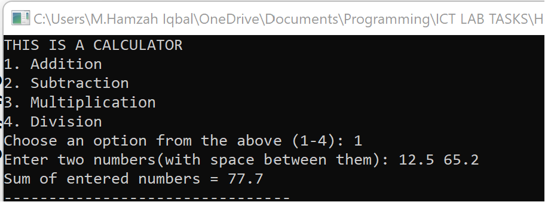
Figure 1 Addition

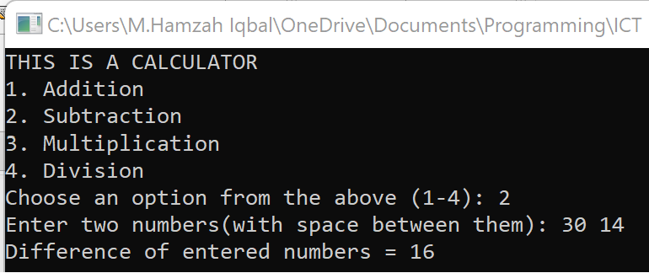
Figure 2 Subtraction
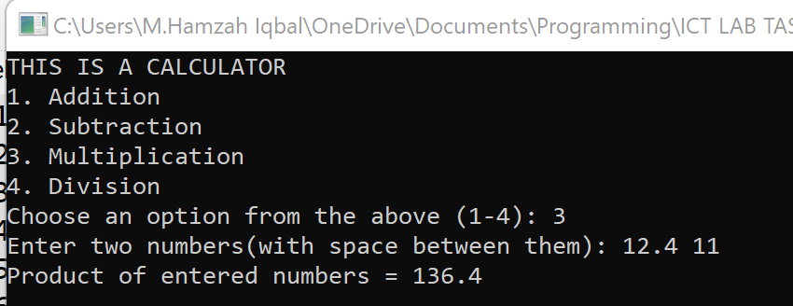

Figure 3 Multiplication

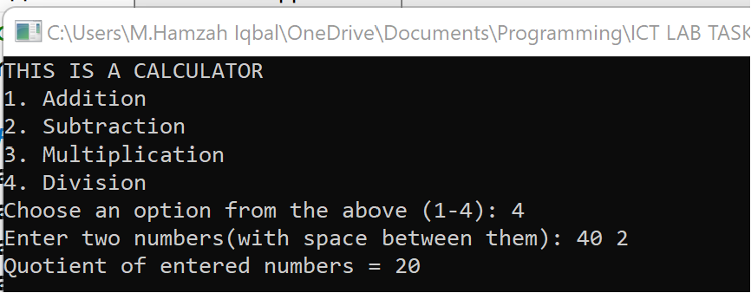

Figure 4 Division
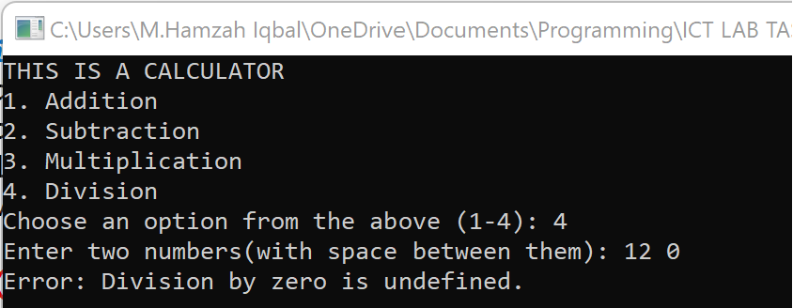

Figure 5 Division by 0 (Infinity Error)

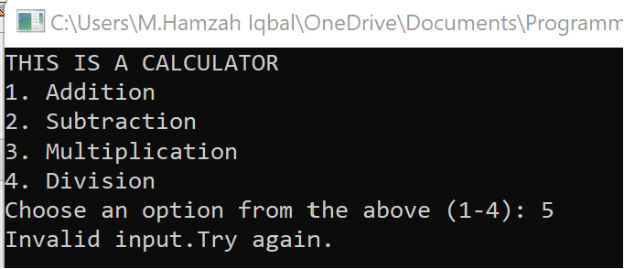

Figure 6 Invalid option Error
Discussion of results and Logic of Task 1:

- The program first displays a menu of operations (Addition, Subtraction, Multiplication, Division) and takes the user’s choice as input.
- Based on the selected option, the program uses a switch-case structure to call the corresponding function (adding, subtract, multiply, or divide).
- Each function takes two numbers entered by the user and returns the result of the chosen operation.
- The program correctly displays the result, while also handling invalid inputs and division by zero to avoid errors.

Task 2

Create a program that converts temperatures between Celsius, Fahrenheit, and Kelvin. The choice of conversion should also be available to the user. You must use “Switch-Case”

Fahrenheit=(5/9×Celsius)+32 Kelvin=Celsius+273.15

Source Code:

#include<iostream>
using namespace std;

int main()
{
int choice; // To store user’s menu choice
double temperature; // To store the entered temperature
double result; // To store the converted result

cout<<"Welcome to the Temperature Converter"<<endl; // Display menu
cout<<"1. Celsius to Fahrenheit"<<endl;
cout<<"2. Celsius to Kelvin"<<endl;
cout<<"3. Fahrenheit to Celsius"<<endl;
cout<<"4. Fahrenheit to Kelvin"<<endl;
cout<<"5. Kelvin to Celsius"<<endl;
cout<<"6. Kelvin to Fahrenheit"<<endl;
cout<<"Choose one of the options above (1-6): ";
cin>>choice;

switch(choice) // Switch-case for conversion
{
case 1: // Celsius to Fahrenheit
cout<<"Enter temperature in Celsius: ";
cin>>temperature;
result = (temperature * 1.8) + 32;
cout<<"Temperature in Fahrenheit = "<<result;
break;

case 2: // Celsius to Kelvin
cout<<"Enter temperature in Celsius: ";
cin>>temperature;
result = temperature + 273.15;
cout<<"Temperature in Kelvin = "<<result;
break;

case 3:// Fahrenheit to Celsius
cout<<"Enter temperature in Fahrenheit: ";
cin>>temperature;
result = (temperature - 32) / 1.8;
cout<<"Temperature in Celsius = "<<result;
break;

case 4: // Fahrenheit to Kelvin
cout<<"Enter temperature in Fahrenheit: ";
cin>>temperature;
result = ((temperature - 32) / 1.8) + 273.15;
cout<<"Temperature in Kelvin = "<<result;
break;

case 5: // Kelvin to Celsius
cout<<"Enter temperature in Kelvin: ";
cin>>temperature;
result = temperature - 273.15;
cout<<"Temperature in Celsius = "<<result;
break;

case 6: // Kelvin to Fahrenheit
cout<<"Enter temperature in Kelvin: ";
cin>>temperature;
result = ((temperature - 273.15) * 1.8) + 32;
cout<<"Temperature in Fahrenheit = "<<result;
break;

default: // Invalid input
cout<<"Invalid choice. Please run the program again.";
break;
}

return 0;
}

Results:

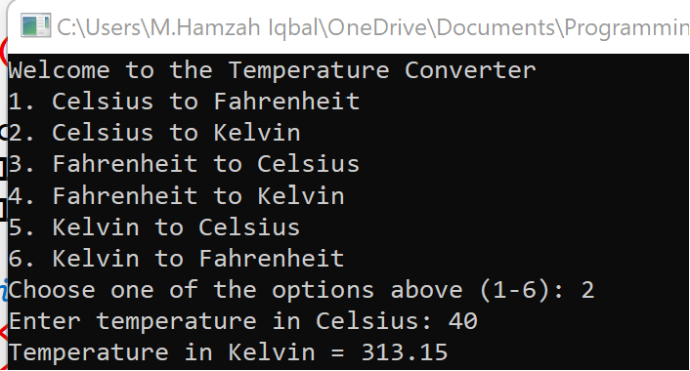
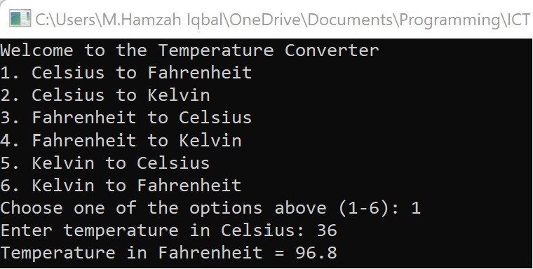
Figure 7 Celsius to Kelvin

Figure 8 Celsius to Fahrenheit

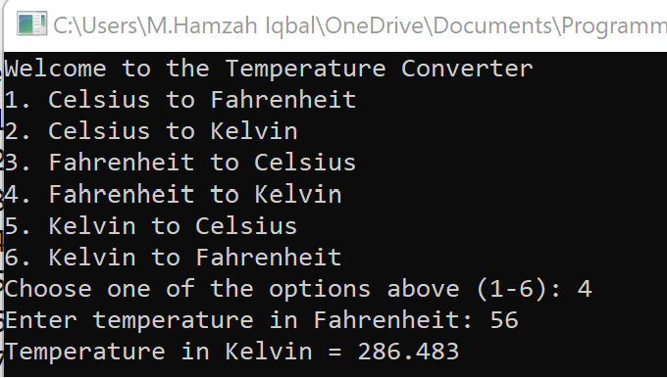
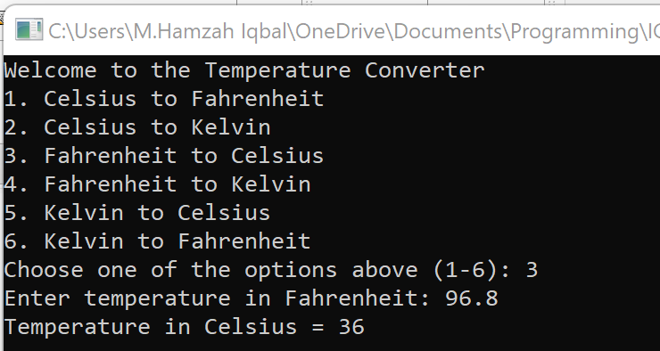
Figure 9 Fahrenheit to Celsius
Figure 10 Fahrenheit to Kelvin

Figure 11 Kelvin to Celsius
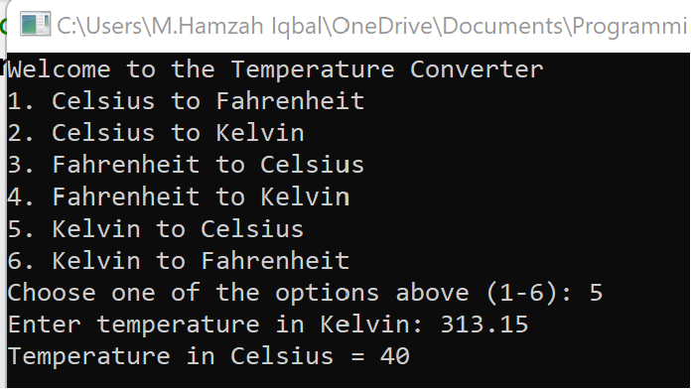
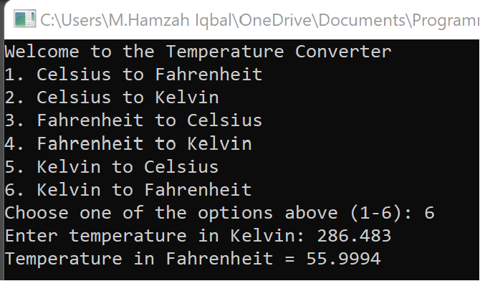
Figure 12 Kelvin to Fahrenheit

Discussion of Results and Logic of Task 2:

- The program displays a menu of six conversion options (Celsius, Fahrenheit, Kelvin) and asks the user to select one.
- A switch-case structure is used to perform the chosen conversion by applying the correct mathematical formula.
- The user enters the temperature in the selected unit, and the program calculates the converted value using standard temperature conversion equations.
- The program outputs the converted temperature or shows an error message if the user enters an invalid choice.

Conclusions

In this Lab we:
- Practiced building C++ programs using functions and switch-case structures.
- Created a calculator program to perform arithmetic operations (addition, subtraction, multiplication, division) with proper error handling.
- Developed a temperature converter program to convert between Celsius, Fahrenheit, and Kelvin using correct formulas.
- Improved our skills in user input handling, conditional logic, and modular programming.
- Gained practical experience in writing structured and reusable C++ code for real-world applications.

